

XJTLU Entrepreneur College (Taicang)
Module Code and Title | ENT208TC Industry Readiness
School Title | XJTLU Entrepreneur College (Taicang)
Assignment Title | Validation Report
Submission Deadline | Friday 15 May, 2026 before 23:59 (Beijing Time, GMT+8)
Session and Group | Session 3 — Group 1
Student IDs | 2359863, 2364371, 2363724, 2363298, 2363858, 2363787
Final Word Count
If you agree to let the university use your work anonymously for teaching and learning purposes, please type “yes” here. | yes

I certify that I have read and understood the University’s Policy for dealing with Plagiarism, Collusion, and the Fabrication of Data (available on Learning Mall Online). With reference to this policy, I certify that:
- My work does not contain any instances of plagiarism and/or collusion. My work does not contain any fabricated data.
By uploading my assignment onto Learning Mall Online, I formally declare that all of the above information is true to the best of my knowledge and belief.
Scoring — For Tutor Use
Student ID | 2359863, 2364371, 2363724, 2363298, 2363858, 2363787
Stage of Marking | Marker Code | Learning Outcomes Achieved (F/P/M/D) |  |  |  |  | Final Score
 |  | A | B | C | D | E
1st Marker — red pen
Moderation — green pen | IM Initials | The original mark has been accepted by the moderator: Y / N |  |  |  |  | Y / N
2nd Marker if needed



Section 1 — Who You Tested With & How
Your participants
Partici  pant | Relevant background / why they were chosen | How you recruited them | Session format
1 | A student who rents accommodation near the XJTLU Taicang campus and owns a pet. This user was chosen because she is familiar with our campus map interface and has a real need for discovering pet-friendly places nearby. This made her suitable for testing the map view, pet location display, and nearby pet-friendly place information. | Recruited through our social circle, focusing on people who own pets | In-person prototype testing
2 | A product testing blogger who has owned cats for many years. She has rich experience using different apps and taking care of pets. She was chosen because she could quickly identify detailed product issues and provide more professional feedback. | Recruited through social media platforms | Online video meeting
3 | A playful Border Collie and its owner. This user was chosen because large dogs are suitable for wearing GPS trackers and usually have a wider movement range, which makes it easier to test the GPS function. The owner had also experienced losing their dog before, so they had a real user need for GPS tracking. | Recruited through local Xiaohongshu posts | In-person testing
4 | A volunteer from an animal protection association. He was chosen because animal rescue volunteers are willing to help lost animals and have a real user need for pet identity recognition. This made his suitable for testing whether the NFC rescue card was clear, fast, and useful in a lost-pet situation. | Recruited through a school club | In-person functional testing and interview
5 | A pet owner or potential pet owner who was interested in pet health monitoring. This user was chosen to test whether AI Photo Check was enough for daily pet healthcare and whether AI Video Check would be useful. | Recruited through personal contact | Online interview and prototype discussion
What you asked them to do
Each session followed the same basic process. First, we briefly explained Pawtrace and its main functions, including GPS tracking, NFC rescue identity cards, and health-related monitoring. Then each participant completed one realistic task based on one user story. Sessions lasted approximately 17–22 minutes in total, including a short introduction, task-based testing, observation, follow-up questions, and discussion of possible improvements.
We asked participants to complete the following tasks:
- Ask the user to explore all functions of the product once, and record the finishing time.
- Each user is asked to complete at least one realistic Pawtrace task. Record the time taken and the parts where the user feels confused.
- Ask the user to give an experience evaluation and function rating for the product, and provide the corresponding user needs.
Follow-up questions
We asked what was confusing, what they expected to happen, and whether they would actually use the feature.
- Map detail :
We asked User 1 to carefully explore the map function and observed whether she could find the corresponding place detail card within the required 20 seconds. She was also asked to explain the actual real-world location shown in the place card. In addition, we asked her to rate the interface layout and visual clarity on a 5-point scale.
- Login task:
User 2 was asked whether she noticed the Guest Mode option; then asked to explore the product functions using both Login Mode and Guest Mode within 2 minutes, and describe the differences between the two modes; After the exploration, she was asked to evaluate both modes and explain which mode made her feel more comfortable and trustworthy when using the app.
- GPS:
We asked User 3 to let the dog wear the GPS tracker and evaluate the dog’s comfort level based on its behaviour. User 3 was then asked to walk the dog within a 1000-metre range, while we observed whether the GPS location was accurate and whether the signal remained stable. User 3 was also asked to give a rating for the GPS accuracy and signal quality. Finally, we asked User 3 whether they had any deeper or potential needs related to GPS tracking.
- NFC:
User 4 was asked to tap the NFC card with a mobile phone. We recorded the time taken for the pet identity card pop-up to appear, and asked the user to rate the clarity and usefulness of the card content.
- AI health assistant:
We asked User 5 to use the AI Photo Check function, evaluate whether it could identify visible health issues, and discuss whether video-based behaviour analysis would be useful for detecting abnormal pet behaviour.
How you captured what happened
We recorded the sessions using observation notes, task completion data, timing, interaction counts, and user comments. During each session, we paid attention to where users clicked, where they paused, what confused them, whether they needed help, and how long each task took. We also collected quantitative evidence, such as detail-finding time, map obstruction count, privacy clarity rating, number of interaction steps, and whether the user could complete the task without help. After each session, we asked follow-up questions about what was confusing, what users expected to happen, and whether they would actually use the feature. The evidence was stored in our user validation record and linked to the relevant design iterations (Section 5 — Evidence Appendix).
Section 2 — What You Found
Finding 1: [Users needed key information to stay visible during interaction]
During testing, we found that users wanted to see the main information without losing context. This was most obvious in the map and place detail task. User 1 could open the nearby place detail card, but the card appeared as a pop-up over the map and blocked part of the location information. User 1 paused and tried to move or zoom the map because they could not view the map and the place details clearly at the same time.
A specific observation was that User 1 spent around 5 minutes exploring the related map functions, but the place detail card still caused confusion because it covered the map. The map obstruction count was recorded as 1 major obstruction, extra scrolling happened 3–4 times, and the map clarity rating was only 2/5 before optimisation.
This finding showed that the interface should not hide important contextual information. After this test, we moved the place detail card from a pop-up to a fixed area below the map. After optimisation, the map obstruction count became 0, the detail finding time decreased from 20 seconds to 2 seconds, and the map clarity rating increased to 4.5/5.
Finding 2: [ “I think app should give users clear options to control their privacy and personal data”]
Another key finding was that users cared about privacy before logging in. User 2 hesitated at the login page because the app did not clearly explain what personal data would be collected. Since Pawtrace involves pet location, owner contact information, and safety monitoring, User 2 expected to see a privacy explanation before using the app fully.
A specific observation was that before optimisation, there was no clear privacy notice entry and no explicit consent step. The privacy clarity rating was only 1/5. User 2’s hesitation showed that users may not trust the product if the login page asks for access before explaining how personal information will be used.
This finding led to two design changes. First, we added a Data & Privacy Agreement to the login page. Second, we optimized a Guest Mode so that users could try part of the product without giving personal data. After optimisation, the privacy notice entry became visible, the consent checkbox was required before full access, and the privacy clarity rating increased to 5/5.
Finding 3: [“I want a reminder or alert before my dog runs too far away”]
User 3’s feedback showed that users did not only want to check where their pet was. They also wanted the app to warn them before the pet was completely lost. P3 understood that GPS could show the pet’s current location, but the user expected an additional safe-area function that could alert the owner when the pet moved outside a defined range.
A specific observation was that before optimisation, GPS function mainly supported passive location checking. The usefulness rating was only 2.5/5 because the user still had to check the location manually. This showed that location tracking alone was not enough for a strong safety experience.
Based on this finding, we added an Electronic Fence function. Users can now set a fence centre and radius on the map, and the system can alert the owner when the pet leaves the safe zone. This changed the GPS feature from passive checking to proactive safety monitoring. The target usefulness rating after optimisation was set at ≥4/5.

Section 3 — What You Changed
What finding triggered this change | What you changed (before → after) | Evidence that the change helped
User 1 could open the place detail card, but the card appeared as a pop-up and blocked part of the map. This made it difficult to view the pet location and place information at the same time. | Before: The place detail card appeared as a pop-up over the map. → After: The place detail card was moved to a fixed area below the map. | Map obstruction count decreased from 1 major obstruction to 0. Detail finding time decreased from 20 seconds to 2 seconds. Map clarity rating increased from 2/5 to 4.5/5.
User 2 hesitated at the login page because the app did not clearly explain what personal data would be collected. | Before: The login page did not include a clear privacy explanation or explicit consent step. → After: A Data & Privacy Agreement was added, a consent checkbox was required before full access, and optimized Guest Mode. | Privacy notice entry increased from 0 to 1. Consent became explicit through the checkbox. Privacy clarity rating increased from 1/5 to 5/5.
User 3 understood the GPS location function, but wanted the app to warn the owner before the pet was completely lost. | Before: GPS only supported passive location checking. → After: An Electronic Fence function was added, allowing users to set a safe area and receive alerts when the pet leaves it. | The safety value changed from passive checking to proactive safety monitoring. The usefulness rating target after optimisation was set at ≥4/5.
User 4 was blocked by login or registration before viewing the NFC rescue card, which was unsuitable for an emergency rescue situation. | Before: Passers-by had to log in or register before accessing the pet identity card. → After: Mandatory login was removed from the NFC rescue process. The identity card opens directly after scanning the NFC tag. | Identity card access success rate reached 100% in test scenarios. Contact information could be accessed within 10 seconds. The rescue flow required no more than 2 clicks after scanning.
User 5 felt that AI Photo Check was useful for visible issues, but not enough for behavioural or hidden health problems. | Before: The health assistant only supported static photo analysis. → After: A YOLO-based AI Video Check function was added to analyse pet movement and abnormal behaviour. | The AI module expanded from Photo Check only to Photo Check + Video Behaviour Analysis. The new feature covers visible skin problems and continuous behavioural abnormalities. The practicality score target was set at ≥4/5.

Most significant change — explained
The most significant change was removing mandatory login from the NFC rescue process. This change was important because the NFC function is designed for an emergency lost-pet rescue scenario, not for normal app browsing. In this situation, the user may be a passer-by who does not know the owner and may not want to create an account.
Before the change, User 4 was blocked by login or registration before reaching the pet identity card. This created serious friction because the main purpose of the NFC tag is to help the passer-by quickly find the owner’s contact information. If the user has to register first, they may give up, especially in a time-sensitive situation.
We changed the NFC flow so that scanning the NFC tag opens the pet identity card directly. The passer-by can immediately view the pet’s key information and the owner’s contact details without logging in. This makes the rescue process faster and more realistic.
The evidence shows that the change helped. After optimisation, the identity card access success rate reached 100% in test scenarios, the owner contact information could be accessed within 10 seconds, and the process required no more than 2 clicks after scanning. This shows that the change directly solved the problem found in the user test.
What you chose not to change — and why
One thing we chose not to change was the basic idea of using AI for pet health support. P5 showed that AI Photo Check alone was not enough, but the user still found it useful for visible issues such as skin problems, wounds, and fungal infections. Therefore, we did not remove AI Photo Check. Instead, we kept it and added AI Video Check to cover behavioural health signals.
We also chose not to make AI health outputs sound like final medical diagnoses. Since AI analysis can only provide suggestions or warnings, the product should not tell users that a pet definitely has a disease. Instead, the health assistant should guide users to observe the pet, conduct a physical check, or contact a veterinarian when necessary.
Section 4 — Limitations
• Sample size: We tested 5 participants in-depth and gathered broader feedback via 25 supplementary questionnaires. However, our sample size remains relatively small and is biased toward the XJTLU-affiliated population, limiting its representativeness. We could not fully reach broader non-XJTLU pet owners, less tech-savvy older users, real passers-by in spontaneous lost-pet situations, and professional veterinarians or animal behaviour specialists.
• Testing conditions: Some testing conditions were different from real-world use. Several testing sessions were based on prototype demonstrations, screen demonstrations, interviews, or short functional tests, rather than long-term daily use. Therefore, the existing test results can show whether our users understood the concept and found the functions useful, but they cannot fully prove the product’s long-term reliability or its performance in real-use scenarios.
• What you could not test: Due to limitations in budget, time, and technical replication conditions, we were unable to verify the product’s performance under multiple extreme conditions or complex environments, such as high-temperature weather, low-temperature weather, heavy rain, and strong wind. Some technical functions also could not be tested in a comprehensive and complete way: GPS accuracy and the Electronic Fence alert function still require longer testing in different outdoor environments; the NFC card function should also be further validated in more time-sensitive lost-pet scenarios involving real passers-by; for AI Assistant, the accuracy of photo and behavior recognition still needs to be further verified through more real-world cases and feedback from professionals.
Section 5 — Evidence Appendix
Reference | What it contains | Link
A1 | P1: Map View and Place Detail Card. This file also includes the overall Purpose of Validation, User Testing Process, and Opening Script for the five task-based user tests. The P1 section includes the user story, user activity, validation criteria, map pop-up obstruction feedback, quantitative evidence before and after optimisation, and the iteration decision to move the place detail card below the map. | OneDrive:  Interview,Session Transcript-User 1.docx
A2 | P2: Data Privacy and Login Trust. Includes the user story, login and Guest Mode testing activity, validation criteria, user feedback on missing privacy explanation, quantitative evidence before and after optimisation, and the iteration decision to add the Data & Privacy Agreement, consent checkbox, and Guest Mode. | OneDrive:  Interview,Session Transcript-User 2.docx
A3 | P3: GPS Tracking and Electronic Fence. Includes the user story, GPS tracker testing activity, dog comfort observation, GPS accuracy and signal quality feedback, validation criteria, user feedback on passive GPS checking, quantitative evidence before and after optimisation, and the iteration decision to add the Electronic Fence function. | OneDrive:  Interview,Session Transcript-User 3.docx
A4 | P4: NFC Rescue Card. Includes the user story, NFC scanning task, pet identity card access, owner contact information retrieval, validation criteria, user feedback on login friction in an emergency rescue scenario, quantitative evidence before and after optimisation, and the iteration decision to remove mandatory login from the NFC rescue process. | OneDrive:  Interview,Session Transcript-User 4.docx
A5 | P5: AI Photo Check and AI Video Check. Includes the user story, AI Photo Check testing activity, validation criteria, user feedback on the limits of static photo analysis, quantitative evidence before and after optimisation, and the iteration decision to add YOLO-based AI Video Check for abnormal pet behaviour and hidden health signals. | OneDrive:  Interview,Session Transcript-User 5.docx
B1 | Session recordings or screen captures: 5 in-depth users and a subset of survey participants. | OneDrive:  B1_Session recordings or screen captures
B2 | Observation notes and rating sheets for the five task-based user tests, including timing data, interaction counts, confusion points, ratings, and help-need records. | OneDrive:  B2_Observation+Notes+and+Rating+Sheets.pdf
C1 | After refining the product's features, we invited 25 individuals to participate in a second round of product trials. The questionnaire respondents included XJTLU students, parents, teachers or staff, and animal rescue volunteers. We documented their feedback through various channels—including face-to-face conversations and WeChat correspondence—and compiled the results into this table. | OneDrive:  Supplementary Questionnaire_Summary.xlsx
C2 | Compilation of Pre- and Post-Iteration Screenshots and Problem Descriptions (Feishu Shared Document. These are the records of Group 1 during the collaboration) | FeiShu:  https://tcnhceok8pbi.feishu.cn/wiki/P8KbwZpRgiMxYrkY9kNc5WUenjb

For A1–A5 and C1, you can also find them at our GitHub link:
https://github.com/jeremyzhao613/Group1-pawtrace/tree/bccb632371c949f633d98cd254c2a1039282331f/validation-report%EF%BC%88User%20testing%20and%20product%20improvement%EF%BC%89
Appendices
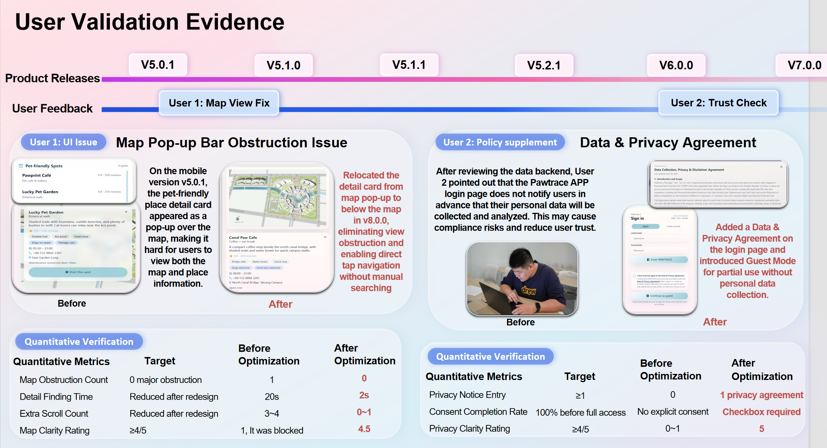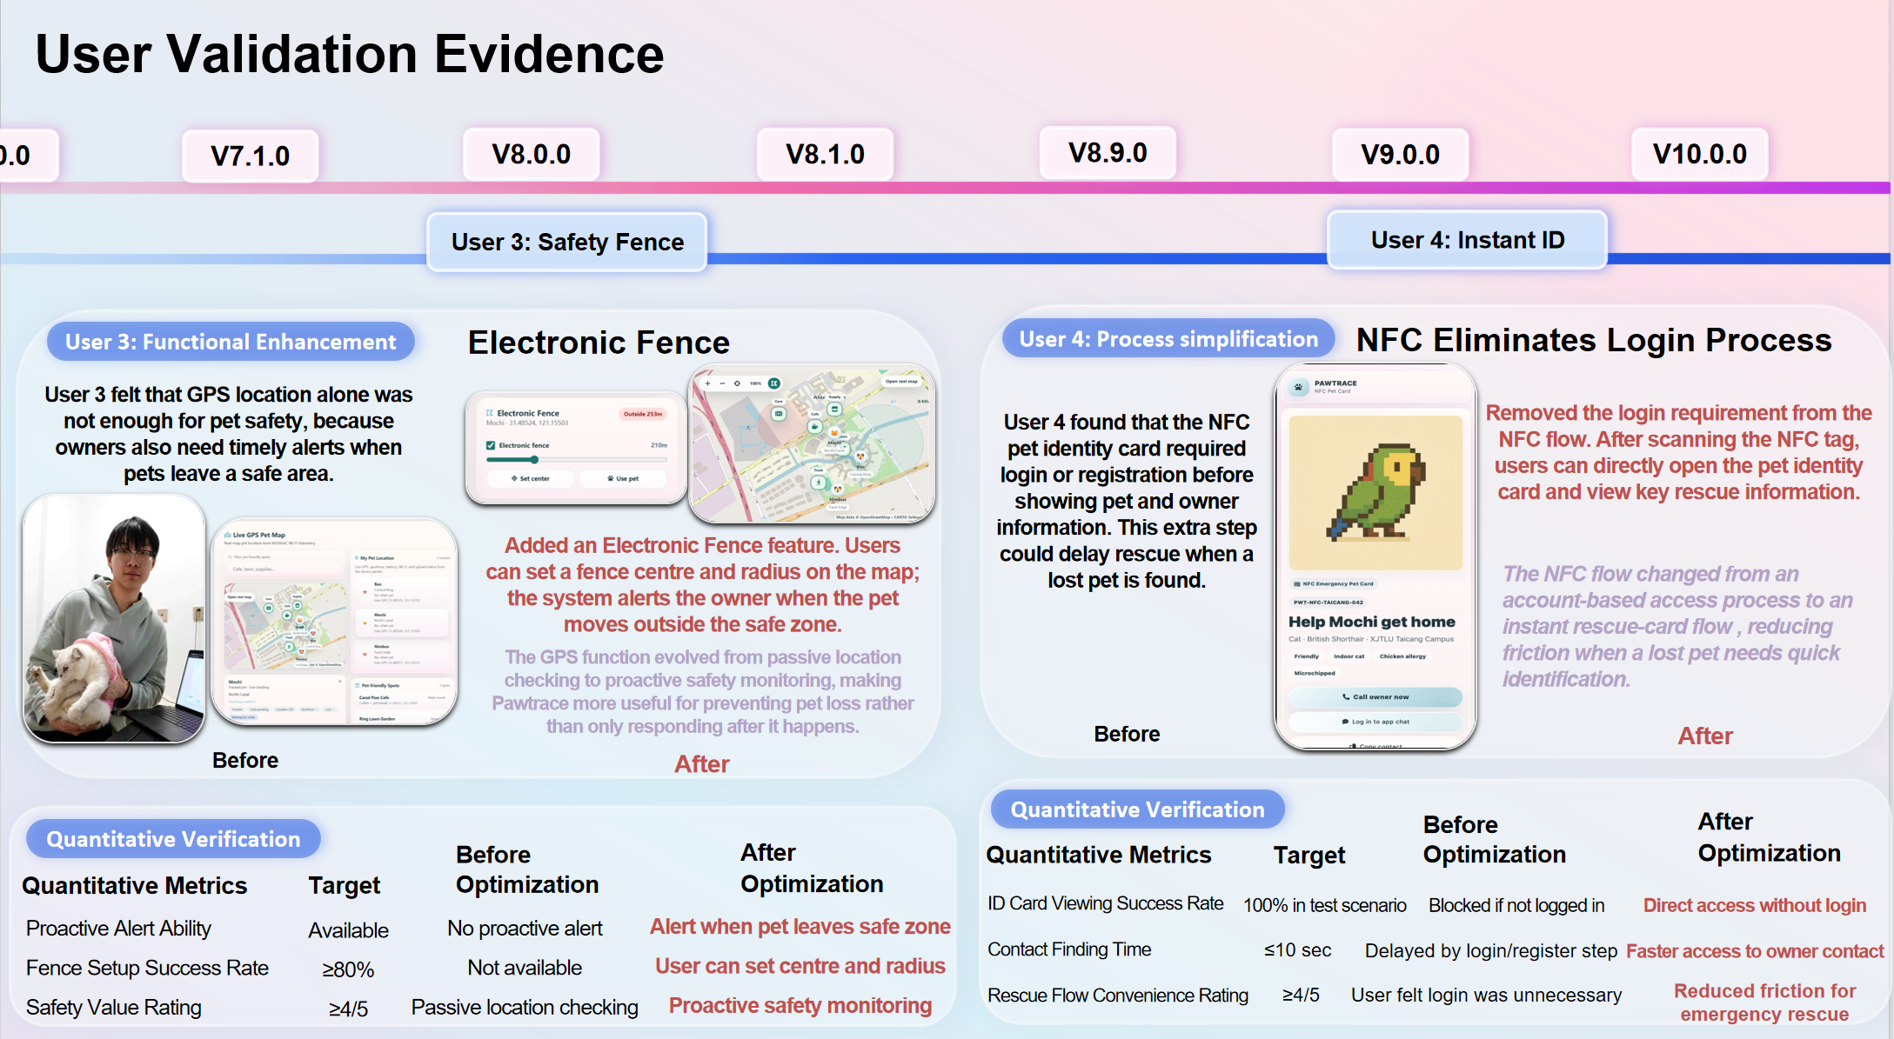

Appendix A. Photos of Interview/Session Transcript
Appendix A presents, in a straightforward manner, the content linked within Part A of Section 5—Evidence Appendix. The purpose of this is to facilitate ease of viewing.
Figure 1：User validation evidence record — P1: Map View and Place Detail Card.
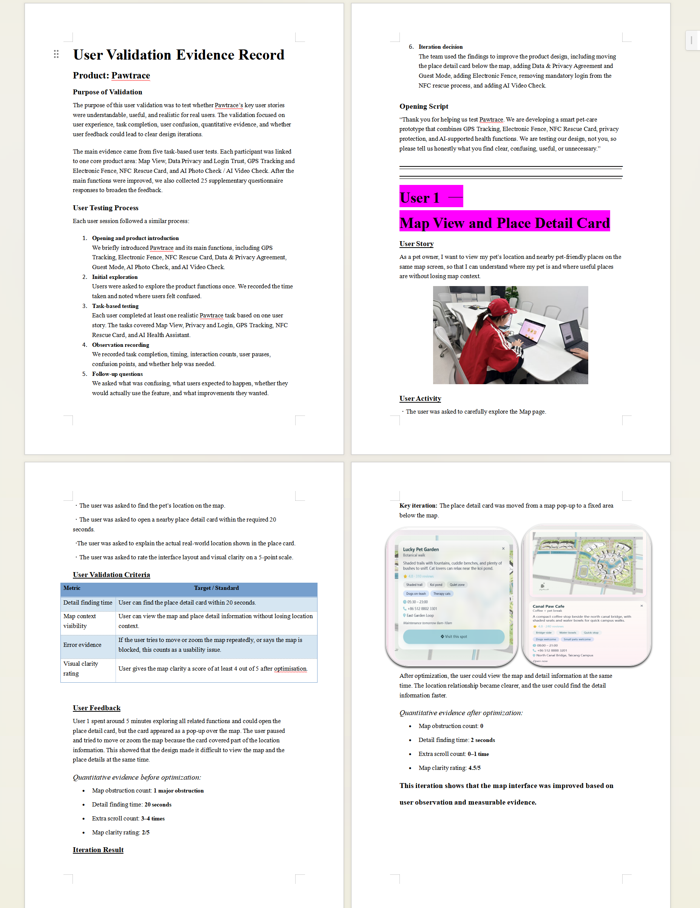
Figure 1
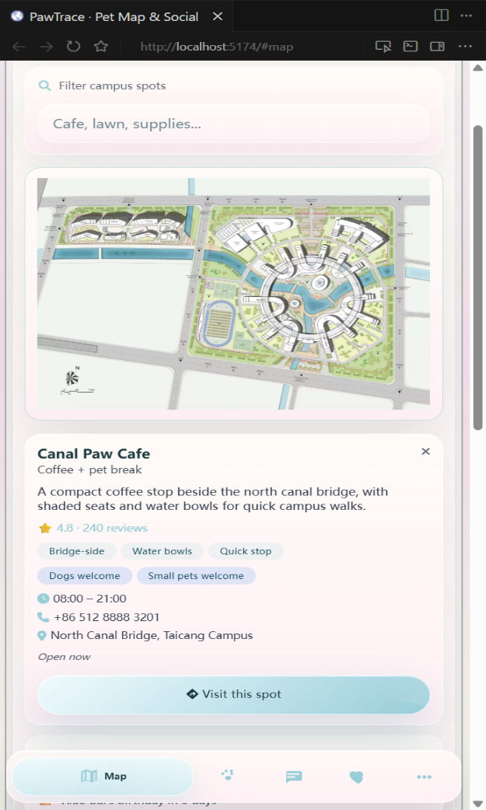
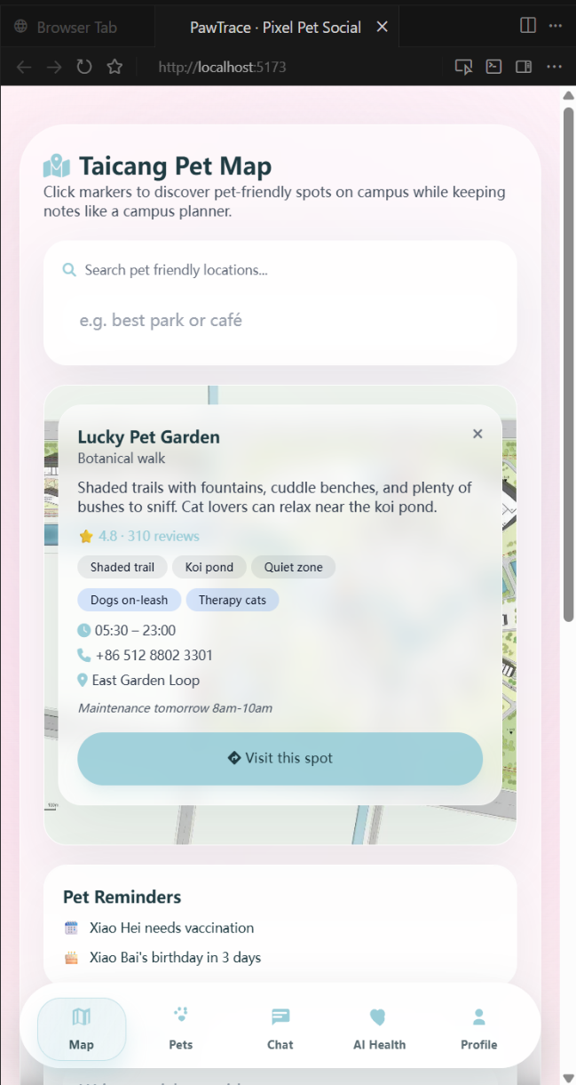
Key iteration: The place detail card was moved from a map pop-up to a fixed area below the map.

Figure 2：User validation evidence record — P2: Data Privacy and Login Trust.
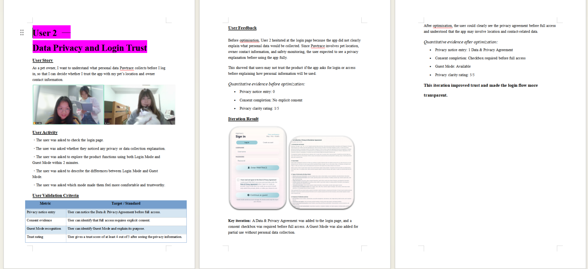
Figure 2
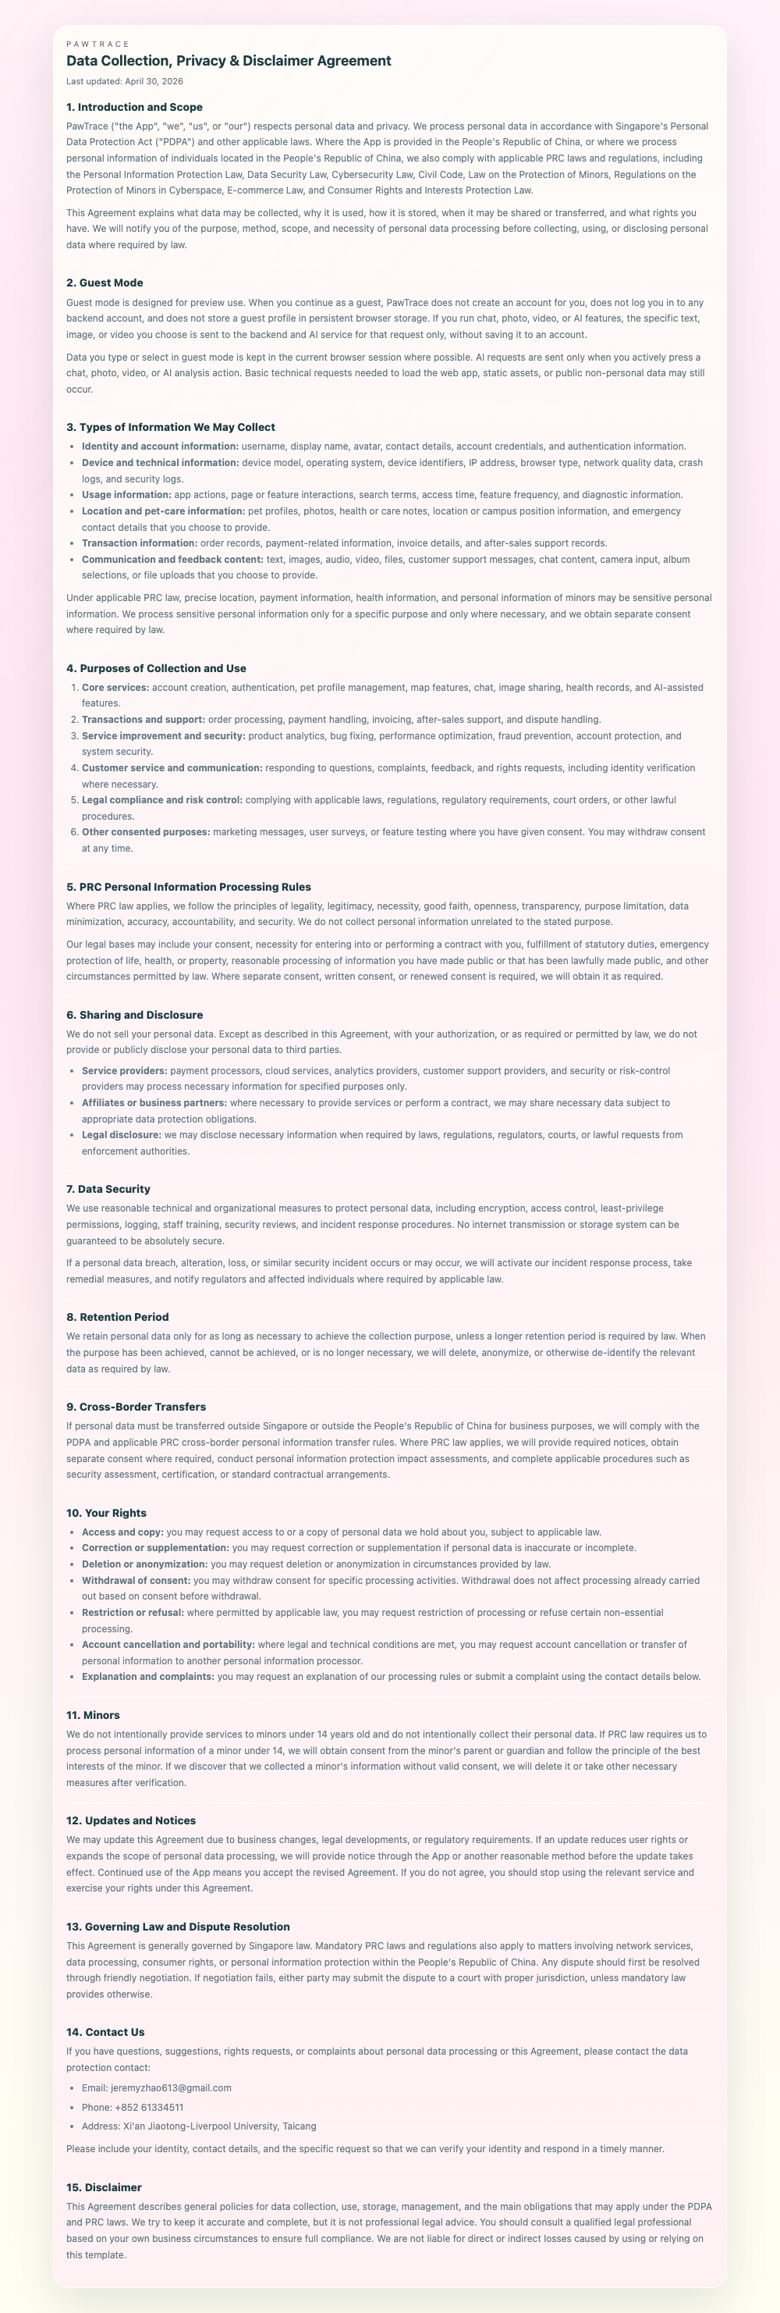
Key iteration: A Data & Privacy Agreement was added to the login page, and a consent checkbox was required before full access. A Guest Mode was also added for partial use without personal data collection.
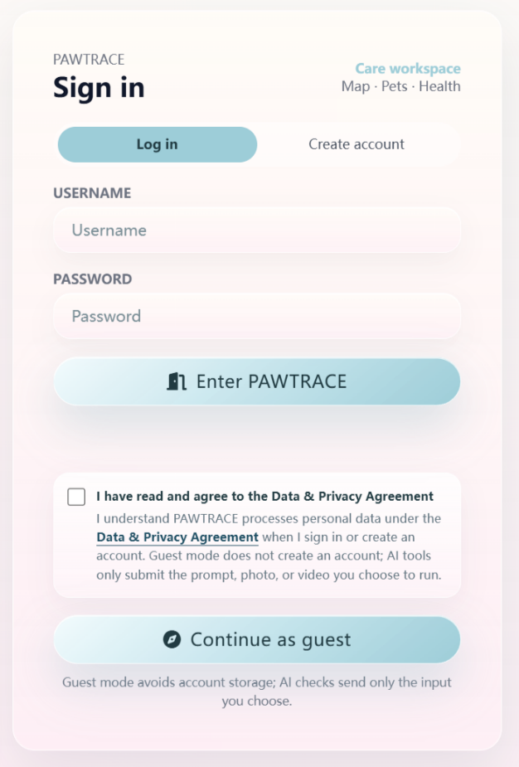

Figure 3： User validation evidence record — P3: GPS Tracking and Electronic Fence.
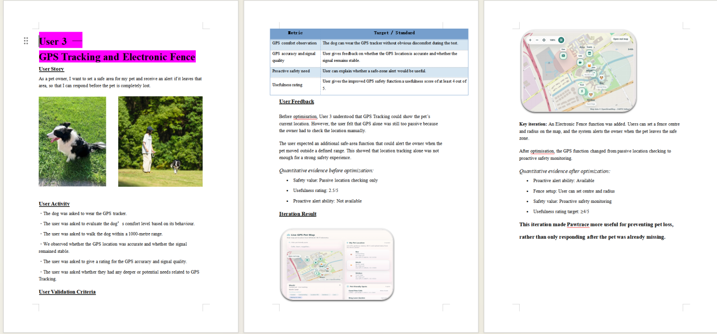
Figure 3
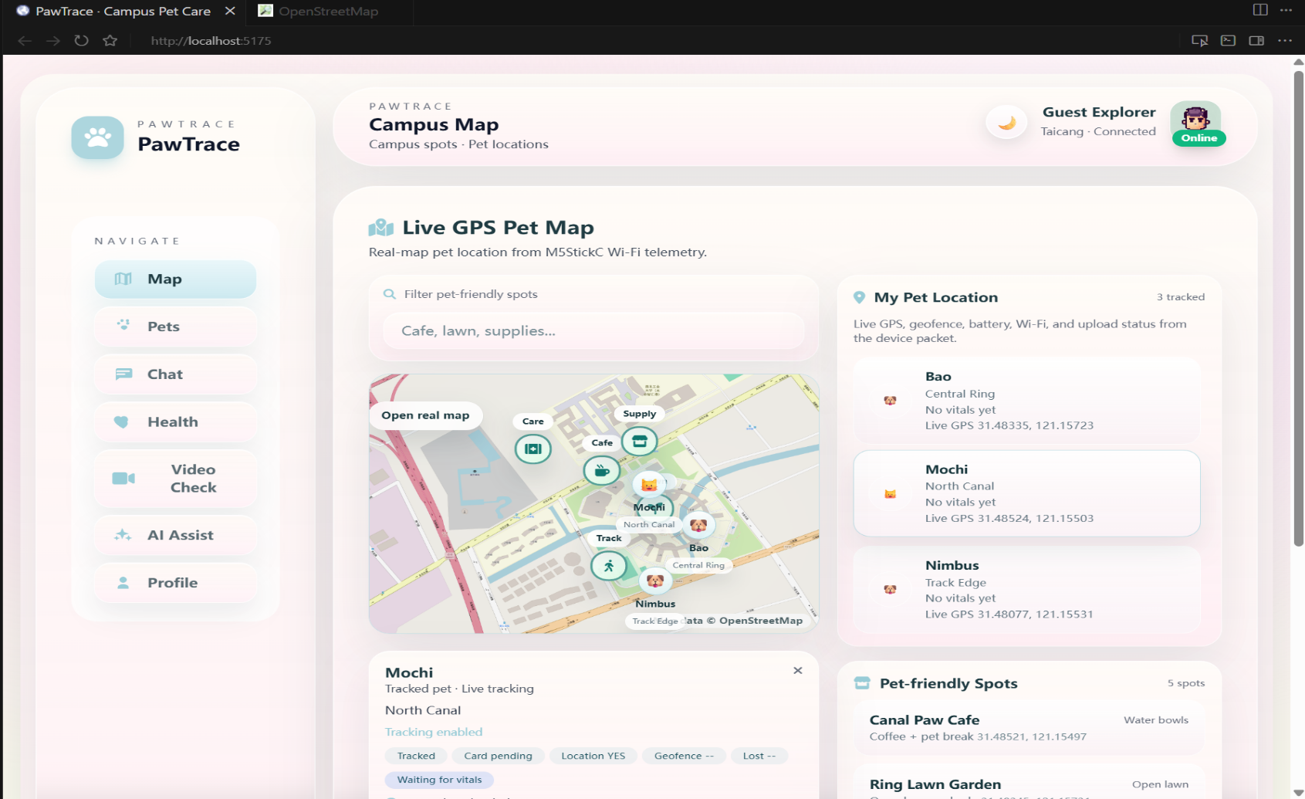
Iteration ResultKey iteration: An Electronic Fence feature was added. Users can now set a fence centre and radius on the map, and the system alerts the owner when the pet leaves the safe zone.
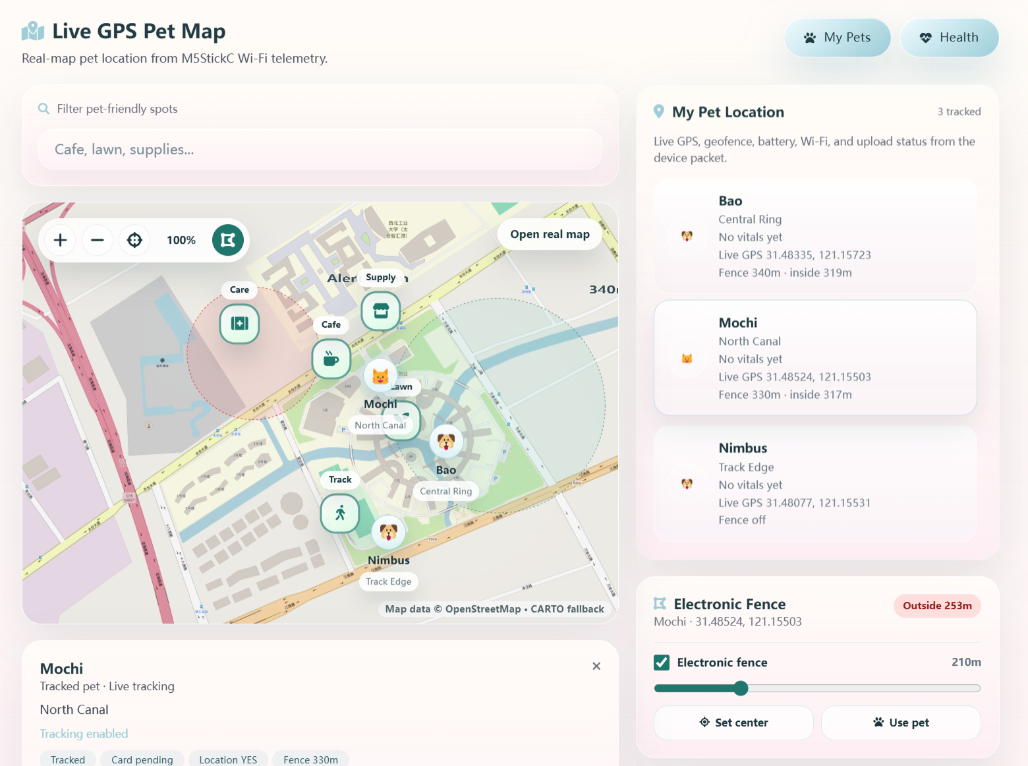
Figure 4：User validation evidence record — P4: NFC Rescue Card.
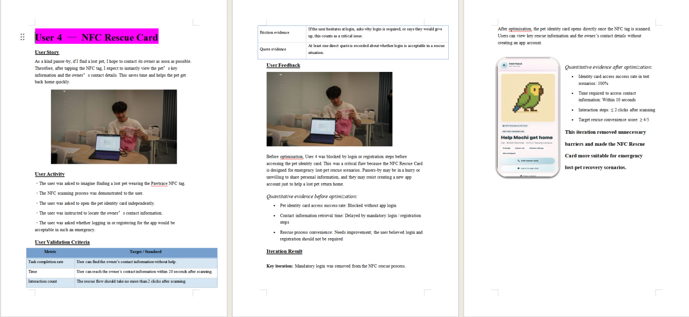
Figure 4
Figure 5：User validation evidence record — P5: AI Photo Check and AI Video Check.
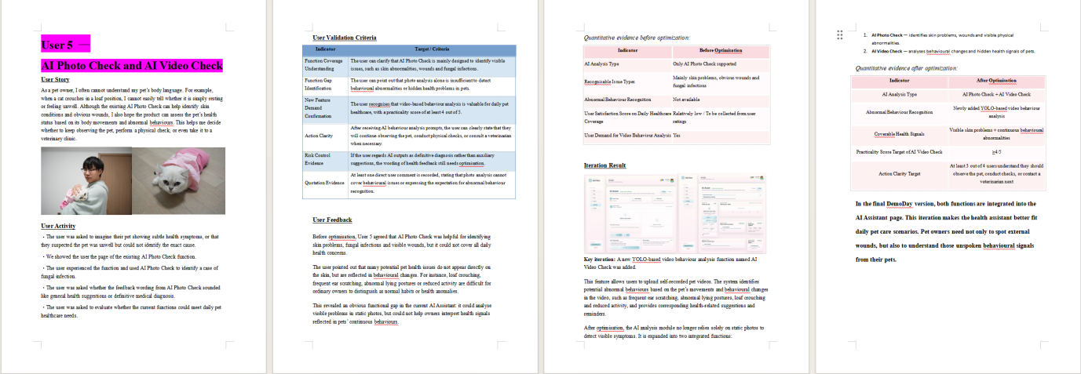
Figure 5
Appendix B. Moments from User Testing
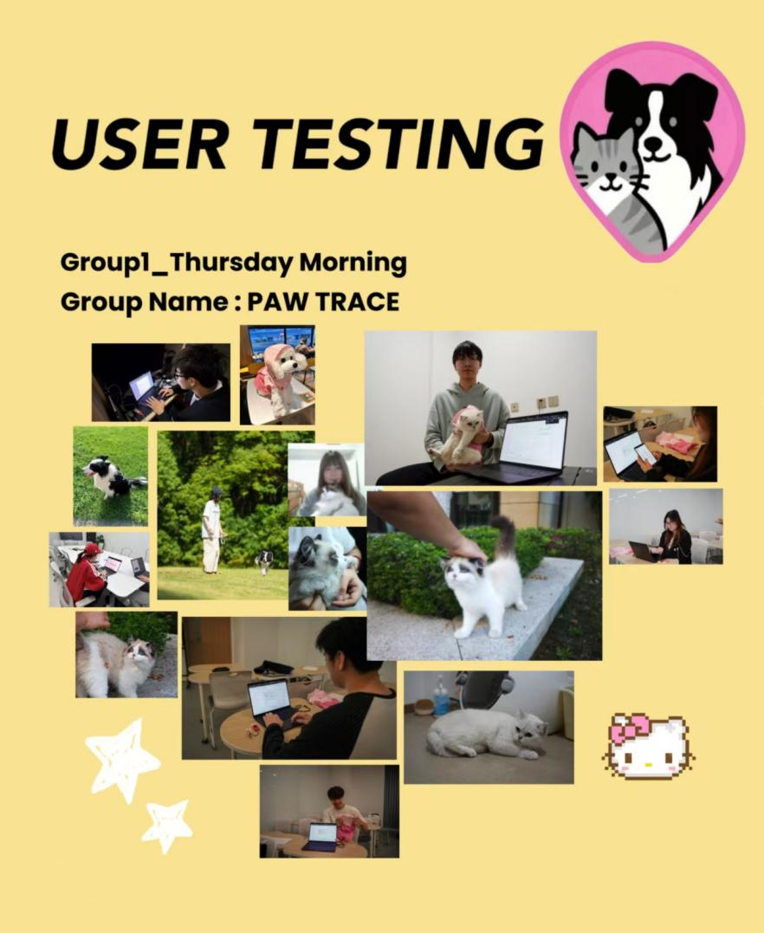
Figure 6
Appendix C. Photos of ‘Data Export for 25 Supplementary Questionnaires’
Appendix C presents, in a straightforward manner, the content linked within Section C1 of Section 5 — Evidence Appendix. The purpose of this is to facilitate viewing.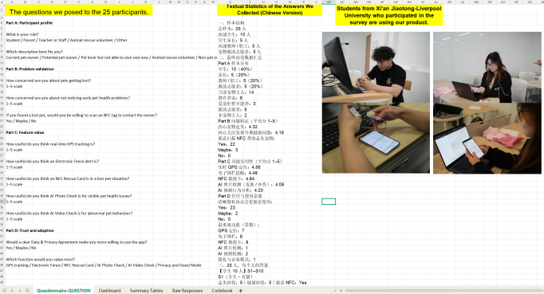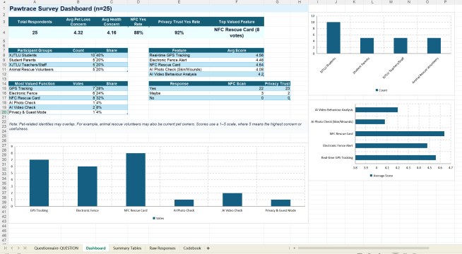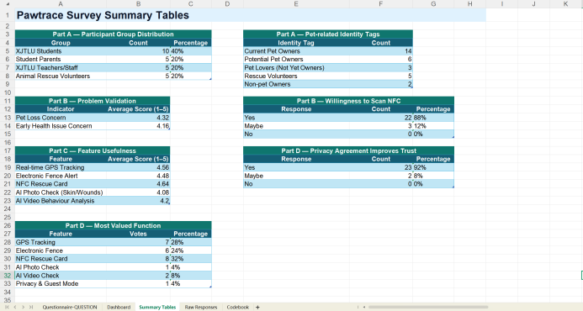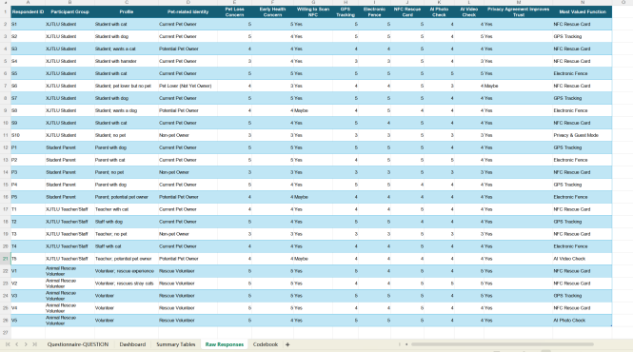
Figure 7
All images are available on GitHub. Please refer to GitHub for more details.

